Date | 12/3/26
Team ID | 6997f7d0b750b5acb2d66ce7
Project Name | Plugging into the Future: An Exploration of Electricity Consumption Patterns
Maximum Marks
Project Design Phase-II Data Flow Diagram & User Stories

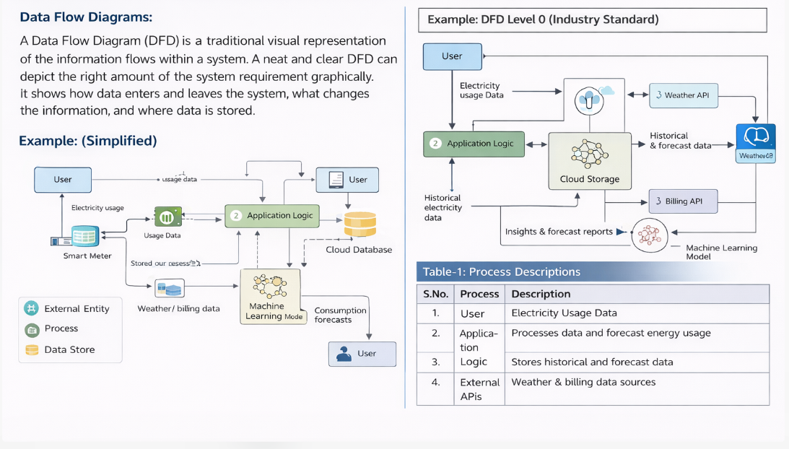

User Stories

